WebAPI
Exercise 4
- Code
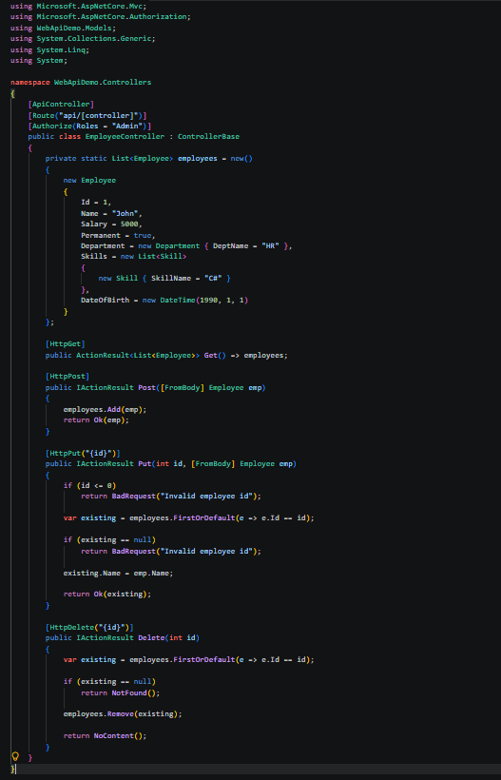

- Output
PUT/api/Employee/{id}
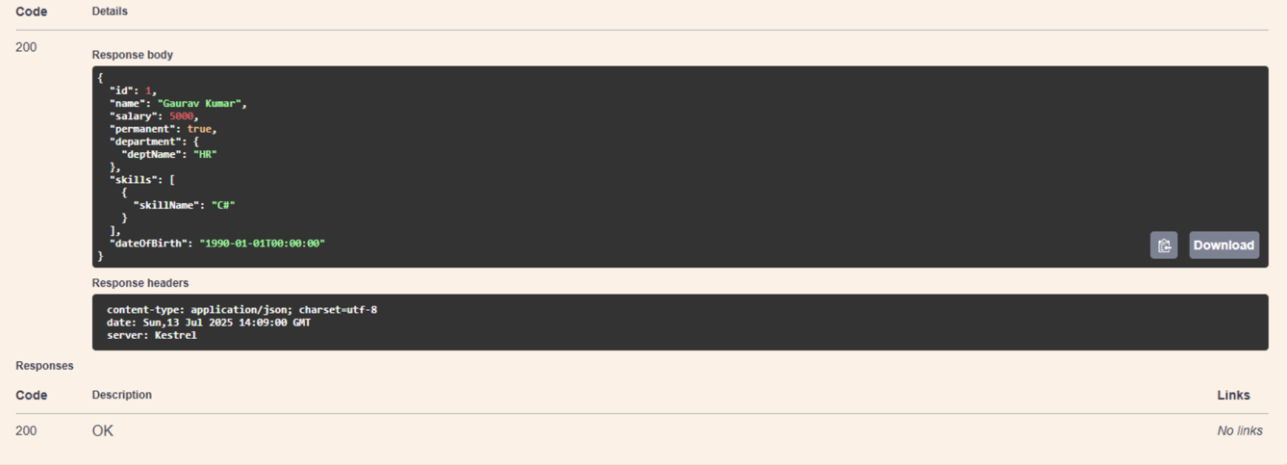

DELETE/api/Employee/{id}

